I. The Empire Strikes: Vietnam and the Myth of the Good Empire

1. Casualties of War
2. American
3. 60,000 deaths
4. 150,000 casualties
5. Vietnamese

a. 3 million, 2 million civilians deaths

b. 8 million, 5.3 million civilians (one third women, ¼ children)

casualties

c. amputees, blindness, cancer, birth defects

d. total population 35 million, 19 million in south.

3. Vietnam

a. cratered

b. poisoning of Vietnam “Only you can prevent forests”

c. burned

4. Myth of My Lai

1. not an exception
2. Work Crimes Working Group

300 confirmed war crimes

500 allegations

Kill Anything That Moves

1. Every branch of the service, every division, every sector
2. Operation Speedy Express

e. Tiger Force

1. Post-colonialism and the Grand Strategy

C. “The Story” began for some of us in 1964

1. Tiny democracy of South Vietnam invaded by Communist North Vietnam.

2. U.S. needs to intervene

a. as the “good empire” in defense of democracy of South Vietnam

b. stop the spread of communism, a monolithic totalitarianism

spreading by force and subversion throughout the world

c. domino theory

3. In an act of war, North Vietnam attacked the U.S., right to self-defense.

4. War going well: evening television “body count”

D. “A Bright Shining Lie”

1. Daniel Ellsberg and the Pentagon Papers (PP)

2. Pentagon Papers

a. reality: Vietnamese independence a threat to grand strategy

b. “rotten apple”:

i. political and economic independence

ii. resources for its own people

iii. Declaration of Independence

E. Empire’s involvement

* 1. Despite Atlantic Charter, Roosevelt reassures France

2. "Top Secret - Sensitive" " It is thoroughly understood that French sovereignty will be re-established as soon as possible throughout all the territory, metropolitan or colonial, over which flew the French flag 1939."

F. Ho Chi Minh the nationalist leader of Vietnam

1. Ally in WWII - Vietminh

2. After WWII: Declaration of Independence based on US and French

They have enforced inhuman laws…they have built more prisons than schools. They have mercilessly slain our patriots, they have drowned uprising in rivers of blood. They have fettered public opinion…they have robbed us of our rice fields, our mines, our forests, and our raw materials…They have invented numerous unjustifiable taxes and reduced our people, especially our peasantry, to a state of extreme poverty…from the end of the last year, to the beginning of this year…more than two million of our fellow-citizens died of starvation...The whole Vietnamese people, animated by a common purpose, are determined to fight to the bitter end against any attempt by the French colonialists to reconquer our country.”

3. Eight letters to the US listing their grievances and

asking to be recognized

a. injustice

b. massive starvation

4. US ignored request for recognition, literally

5. Ho Chi Minh to U.S. and world

a. French attempting to recolonize

b. US commitment violation of international law and the Atlantic Charter

G. US support of France

1. Chinese and British forces occupied Vietnam at end of WWII. U.S. persuades them to leave.

2. U.S. provides transportation for French soldiers to return and

and recolonize Vietnam

3. Vietnamese resist: 1946 French bombed Haiphong in attempt to retake

Vietnam

4. French Indochina eight year war

5. French lost and by the end of the war US was

paying 80% of cost of war, incl 300,000 weapons

6. US Covert intervention 1953

a. “Third Force”

b. Undermine communism

i. terrorism: violence against civilians

ii. blame it on communists

7. 1954 during battle of Dienbenphu

a. French trapped

b. US offers two atomic bombs to French, the offer

is rejected

c. US considers using atomic weapons itself seeks

political support from British - no

H. Geneva Peace Accords

1. Temporary settlement of the Vietnam into North and

South in 1954

a. National elections to reunify in 1956 (Art 14)

b. Accords stated, “these Agreements recognize and guarantee, independence, unity and territorial integrity of Vietnam (Article 6 and 7 of the final Declaration).”

c. No new troops (Article 16)

d. No new bases (Article 18)

3. US realizes that Ho would win (PP)

a. Joint chiefs of staff, US Congress

b. Ho would win election, imperial powers would lose Vietnam, Cambodia, Laos, Thailand

4. US decides on policy to undermine Peace Accords

a. creates "country": **Pentagon Papers: "South Vietnam was essentially a construction of the United States."**

b. set up puppet government in 1954

i. US put Diem a Catholic from New Jersey in charge of a Buddhist country

ii. no popular support

iii. only support from U.S. and the colonial elite

5. Diem

a. oppression of peasants economically

b. reversed land reform returned 1,500,000 acres to

French land owners

c. repression of dissent through military with US

support: 60,000 political prisoners

d. cancelled the elections

I. Resistance

1. 1958 resistance to Diem in villages

2.1960 the National Liberation Front was organized,

or Viet Cong

a. mass based political-social organization in over

2500 villages

b. **Pentagon Papers 1962: Only the Viet Cong had**

**any wide based popular support**

U.S. government analyst Douglas Pike, “in the 2561 villages of South Vietnam, the National Liberation Front created a host of nation-wide socio-political organizations in the country . . .the purpose of this vast organizational effort was…to restructure the social order of the village and train the villages to control themselves.” By 1962, there were an estimated 300,000 NLF members

3. 1961 Kennedy

a. covert military operations in the North,

b. more "advisors" to 16,000 which violated Peace Accords

II. The American War

A. Pacification (early 60s)

1. US military strategy to defeat the Viet Cong: two part

a. kill them

i. not battles, but attrition

ii. body count becomes all important

iii. if they are dead they are VC

iv. RW: ‘someone counted the arms and legs

and divided by four’

b. deny them support

i.BSL: “Terrorize the peasants out of supporting

the Viet Cong”

ii. RW: “After dark, they are Viet Cong.”

2. Method:

a. rules of engagement: shoot anyone that runs, looks up, waves

b. 1961-62 US began bombing, napalming, and defoliating with Agent Orange (cancer causing agent - dioxin)

c. burn villages “Zippos jobs”

d. destroy crops and animals

e. destroy jungle cover

f. force peasants to relocation camps aka "concentration camps" “strategic hamlets”

d. Colin Powell: "this is what we did, films of it"

“Hearts and Minds”

3. “Unintended consequences”: “Bright Shining Lie”

a. Vann: “the bombing kills many more civilians than it ever does VC and as a result makes new VC”

b. Porter: “it was not a question of killing some

noncombatants, it was a question of killing

mostly noncombatants.”

B. Resistance to Diem and Pacification

1. Buddhist monks protesting forced conversions to Catholicism in Hue 1963

2. Buddhist monks immolating themselves

3. increased resistance from Viet Cong and aid from

north

C. Losing but . . . Amazing- David attacks Goliath - Gulf of Tonkin August of 1964

1. “The Story”:

a. we were attacked, act of war

b. torpedo boats unprovoked attack

2. Lie,(PP)

a. destroyer was in Vietnamese territorial waters

b. spy mission

c. covert operation to infiltrate the North

d. “no attack”

3. Gulf of Tonkin Resolution

a. gave president power to wage war

b. without declaration of war,

c. Supreme Court was supremely silent

1. Johnson: As the “good empire” we are going to pursue a policy to win the "Hearts and Minds" of the Vietnamese people
2. “Quantification” of War
3. Application of technology and administrative efficiency
4. “scientific and efficient”
5. Goal: “kill more than enemy could replace”
6. “body count” is most important thing
7. measure of success from Pentagon to patrols

f. rational production of dead people: “box scores” and “kill boards”

four body parts equal four kills

if dead then VC, look up, act unnatural, violent conduct

overkill (amount of ammo fired per soldier 26x WWII)

g. easy given racism, ethnocentrism

“piddling piss ant little country”

“the outhouse of Asia”

‘Kill ‘em all and let God sort them out”

“gooks”

“mere-gook-rule”

“. . . just some more dead gooks. The sooner they all die the sooner we go back to the World.”

h. new efficient weapons never, or seldom, used before

war as a laboratory

white phosphorous

BLU4 250 steel pellets “pineapple”

CBU-24 (600 BLU, 200,00 steel fragments) ‘guava”

Enough for every man, woman and child in Vietnam, Laos and Cambodia

2. US began 'saturation bombing' of NV

3. U.S. troop build up 1965 200,000, by 1968 there were 550,000

3. U.S. massive bombing of SV began,

a. 7+ million tons

b. 20 million bomb craters

c. more than 4x the number of bombs dropped in

WWII (Europe and Asia)

d. one 500lb for every person in South

e. 90% of the bombs were dropped on SV

f. reparations $87 per rubber tree and $34 per

civilian

g. bomb Laos 1965-1972 : 2.1 million tons ( more than Germany and Japan combined)

h. Laos and the Plain of Jars

i. 540 Hiroshima sized atomic bombs

4. napalm

a. jellied gasoline with phosphorous

b. Fallbrook

c. Vietnamese woman holding a badly burned child?

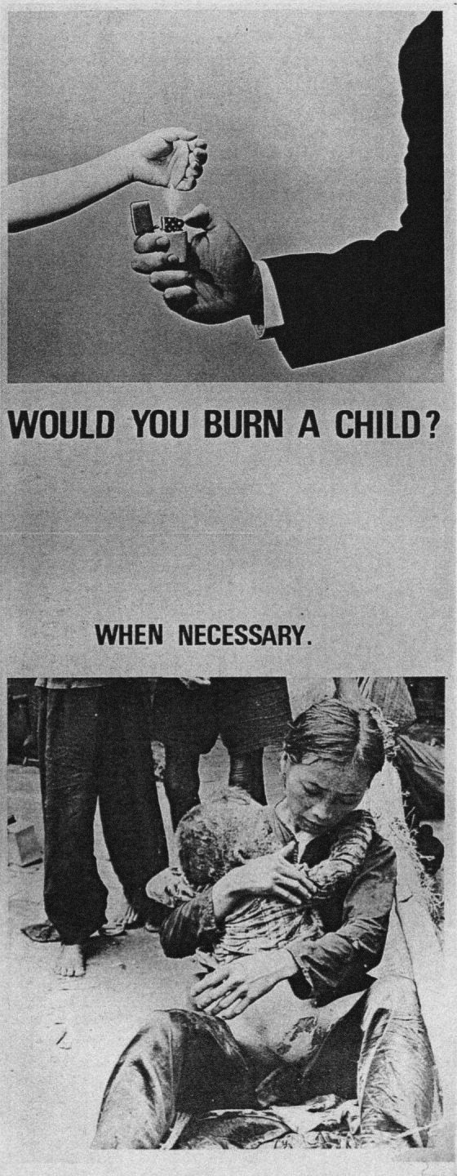

Women Strike for Peace,[1] a prominent pacifist group during the Anti-Vietnam War Movement, used posters protesting the use of napalm. And example (figure 26) is a poster that uses an excerpt from Martin Luther King Jr.’s *Beyond Vietnam* Speech. The text reads: “If America’s soul becomes poisoned, part of the autopsy must read Vietnam.”[2] The children shown in the poster are children burned by napalm. Michele Oka Doner, a Michigan University undergraduate art student, created a series called *Death Masks* (Figure 27)*.* The death masks were ceramic molds of a series of dolls and death masks with tattoos or mutilations. These were understood to be a reference to the victims of napalm.

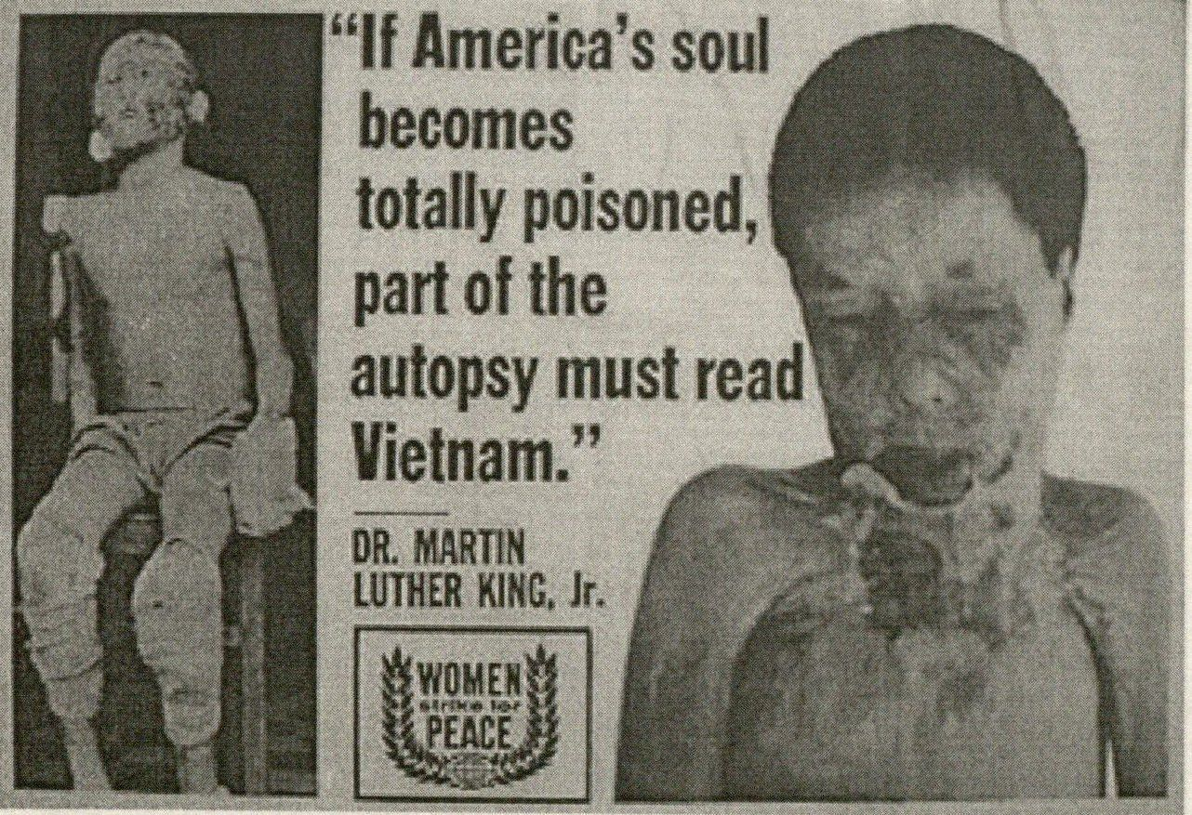

5. Agent Orange and Operation Ranch Hand

a. 20 million gallons of herbicide incl11.2 million gallons of Agent Orange a defoliate meant to

i. destroy jungle as cover

ii. poison rice crops

b. In Vietnam 400,000 deaths and 500,000 birth defects

c. also cancers, immune-deficiency diseases

d. dioxin still in environment - fish, plants, animals,

e. produced, sold, and profited - Dow Chemical

f. sprayed it on our own men

i. 270,000 exposed (cancers: Hodgkin’s disease, prostate, respiratory)

ii. 20,000 awarded $180 million in class action

iii. 6000 compensation from government

g,"The largest contamination of dioxin in the world . . ."

h, 40% sprayed on crops

6. bulldozers, tanks and fires, slaughter of animals

7. Free fire zones -- anyone or anything in the area were considered enemies

a. notify villagers in advance by loudspeaker

from helicopter or leaflets

b. no warning if troops had received fire

c. once civilians move out 'free fire zone'

d. rule ineffective, ignored, civilians didn't understand

e. refugee camps full, no more refugees, but

continue search and destroy

6. Search and destroy -- villages that were suspected of

sympathy were destroyed, people killed, including women and children --

a. "Kill them all and let God sort them out."

b. one area: 167 villages 130 destroyed

7. My Lai 4, in Quang Nai Province, Operation County Fair

a. killed 450 to 500 mostly women, children, and aged, raped and sodomized

are holding *Q: And Babies? A: And Babies* in front of Picasso’s *Guernica*. *Guernica* is a painting that depicts the bombing of the Spanish town of Guernica on April 26, 1937.[3] The demonstrations received world-wide publicity and resulted in the creation of fifty thousand copies of the poster. The poster became ubiquitous at anti-war rallies, marches, and demonstrations.

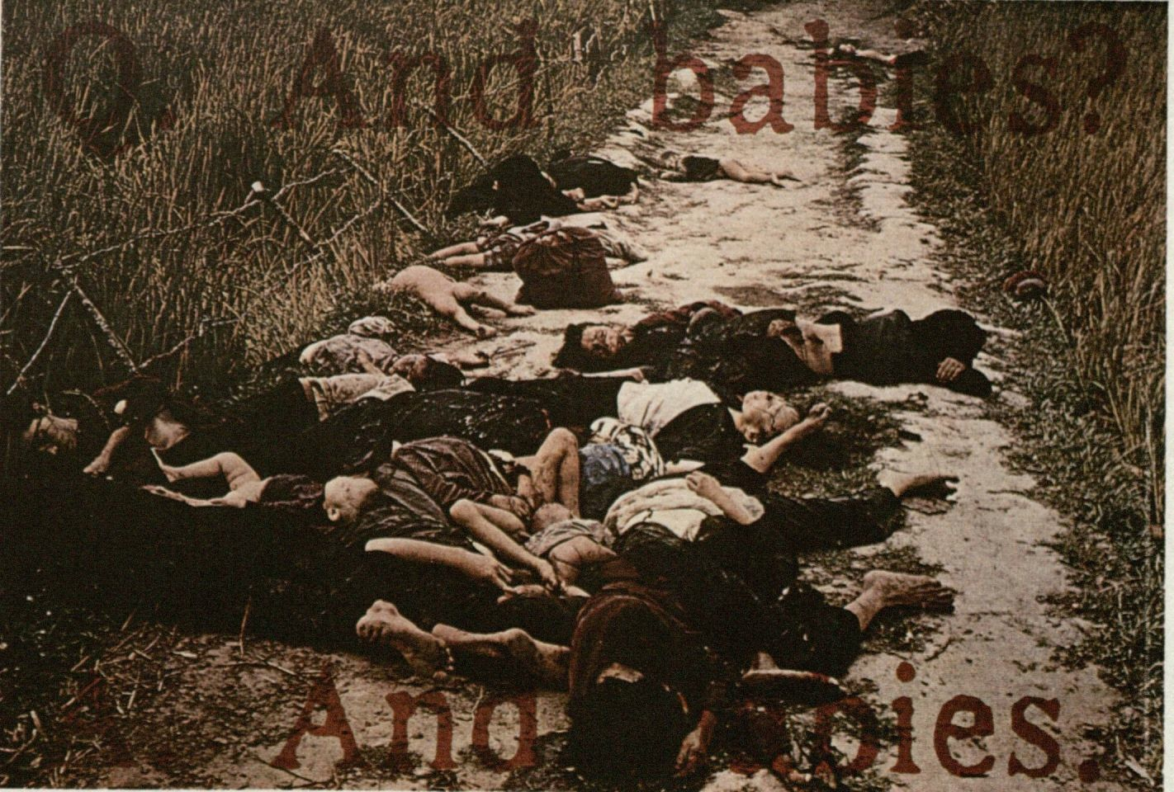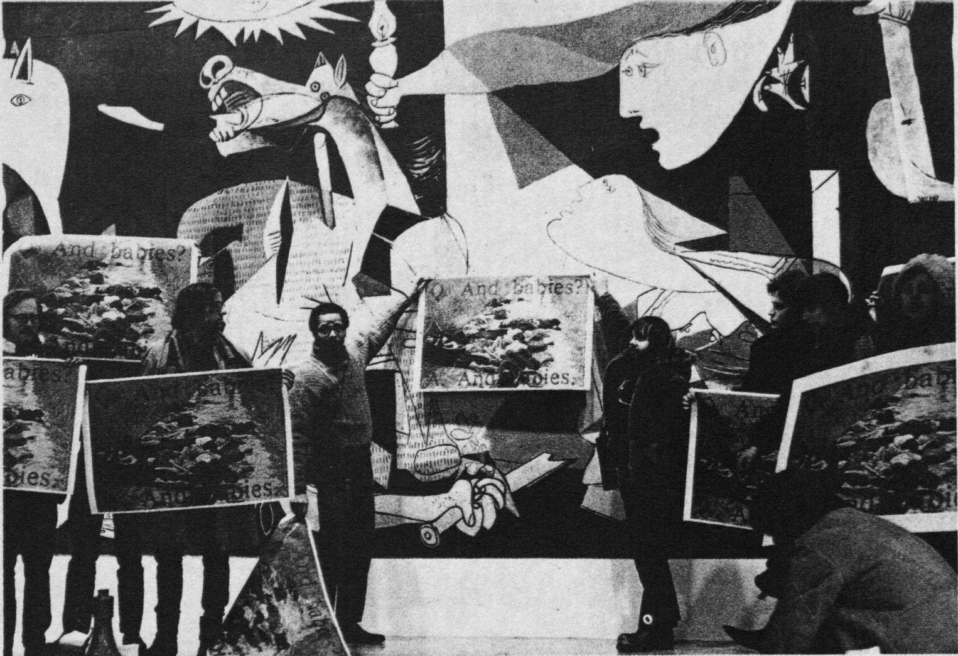

b. cover up - truth / every unit of brigade size

has its My Lai: Oran Henderson Colin Powell

c. Senate Foreign Relations Committee Sen John Kerry re: war crimes

d. Kerry plus 150 honorably discharged and

highly decorated

e. American troops: 'raped, cut off ears, cut off heads, taped wires to genitals, cut off limbs, blew

up bodies, randomly shot civilians, razed villages

like Germans in Russia, shot cattle, livestock, dogs

for fun, poisoned food stocks,

f. Tiger Force

8. Operation Phoenix 25,000 civilians were executed by

CIA without trial and 40,000 to concentration camps

a. Pro-administration analyst, we undoubtedly killed many innocent civilians

b. one village several hundred names, killed several

hundred but no one on the list

9. American Red Cross found systematic brutality in prisoner camps with US soldiers participating in the brutality

E. This doesn't look good, I have a better idea

1. Viet Cong in congressional report 1967, they are redistributing land to peasants -- hearts and minds

2. McNaughton: "There may be a limit beyond which many Americans and much of the world will not permit the US to go. The picture of the world's greatest superpower killing or seriously injuring 1000 non- combatants a week, while trying to pound a tiny backward nation into submission, on an issue whose merits are hotly disputed, is not a pretty one. **It could conceivably produce a costly distortion in the American national consciousness.”**

3. A Great Idea flood the rice fields cause massive starvation and then provide relief: John McNaughton, Asst Sec of Defense

F. Much of this is on TV, after Tet 1968

1. Journalists with TV cameraman in the fighting

a. soldiers killed over 50,000 and 200,000 +

injured

b. body bags

c. US soldiers burning villages and food

d. napalmed children

e. My Lai

f. Saigon police chief shooting unarmed bound

civilian in the head

2. Michael Herr “Dispatches”

3. Neil Sheehan “Bright Shining Lie”

1. David Halberstam “The Best and the Brightest”
2. Soldiers resist

G. Vietnamization

1. already illegally bombed Laos - 75,000 tons of bombs 1964-68, basically destroyed the Plain of Jars and its society

2. Nixon elected to withdraw with honor “end the war and win the peace”

3. Vietnamization: reality

a. 1969 renewed bombing of Cambodia

b. Feb 1971 Lamson 719 ARVN invasion of Laos, US air support

c. May 1971, mined Haiphong harbor and intensify the bombing in North Vietnam.

d. Dec 1972 Christmas bombing

References by Title and Author

*A Fire in the Lake*, Frances Fitzgerald

*Against Empire*, Michael Parenti

*Against the Crime of Silence*, John Paul Sartre

*A Rumor of War*, Philip Caputo

*Beyond Vietnam*, Martin Luther King

*Bright Shining Lie*, Neil Sheehan

*Declaration of Independence of the Democratic Republic of Vietnam*, Ho Chi Minh

*Declarations of Independence*, Howard Zinn

*Dispatches*, Michael Herr

*Fields of Fire*, James Webb

Going After Cacciato, Tim O’Brien

If I Die in a Combat Zone, Tim O’Brien

*Kill Anything that Moves*, Nick Turse

*Lies My Teacher Told Me*, James Loewen

*Manufacturing Consent*, Noam Chomsky

*My Lai 4*, Seymour Hersh

*Necessary Illusions*, Noam Chomsky

*Nemesis*, Chalmers Johnson

*On Western Terrorism*, Noam Chomsky

*Overthrow*, Steven Kinzer

*Peasant Wars of the Twentieth Century*, Eric Wolf

*Pentagon Papers as Published by the NY Times*, Neil Sheehan

*People’s History of the United States*, Howard Zinn

*The Best and the Brightest*, David Halberstam

*The Chomsky Reader*, edited James Peck

*The Trial of Henry Kissinger*, Christopher Hitchens

*The Village of Ben Suc*, Jonathan Schell

*Tiger Force*, Michael Salah and Mitch Weiss

*Vietnam: A History*, Stanley Karnow

*War Powers*, Peter Irons

*Working-Class War*, Christian Appy

1. The Women Strike for Peace played an important role in the anti-draft movement, counseling more than 100,000 young men (Hillstrom).
2. http://www.ratical.org/ratville/JFK/MLKapr67.pdf
3. Guernica is the ancestral lands of the Basque minority and had the population of seven thousand. The Basque opposed the authoritarian dictatorship of Francisco Franco who was backed by Fascist Italy and Nazi Germany.